190322-000334

How to fix broken AX 12a/+ servos

So, your servo isn’t working… they unfortunately break in many varied ways with different methods of fixing them. They are relatively simple to fix if they are fixable which is great news for you! This document will outline:
- Different breakages and how to fix them
- Is it worth fixing?
- Improvements that can be made to your servos

What kind of breakage

Servo has stopped working while driving
This is relatively common with a usual culprit – maxed out the torque - If there is a red light blinking, try restarting the power to the servo to reset any warnings.

If there is no red light blinking try: checking the code, checking the wiring, power, restarting the robot and power etc.

For both options, if that doesn’t work, remove and replace the servo from the robot and check the below categories.

How to test the type of breakage
Plug your servo in to a computer and run the DX utilities code – code that allows you to read information from the servo, read and set Servo ID’s etc.

If no or abnormal response
This means that most likely the on board computer is broken. This is hard to fix and it is not really practical or financially worthwhile fixing it.

A reminder: make sure to test the code and process with a confirmed working servo before making this decision.

If information is returned however the servo making an unusual sound or not moving
This is usually caused from a broken or slipped gear.

Simply unscrew and carefully disassemble the servo, find the broken gear and replace it with a working one – usually a new purchased gear or one from a servo with a broken computer.

Try to get as much grease on the appropriate areas to avoid having to do the process again soon. Also be sure to clean the internals, removing any potential plastic flakes.

Is it worth fixing?

For every problem, at first the decision needs to be made, ‘is it worth solving’. If the cost is too high or if the effort is too time consuming then it is often not worthwhile solving it.

An example of this, it is worth switching out a gear (approx cost $10) however it is not worth while trying to fix the on board computer for a $50 servo.

Improvements that you can make

Upgrading gears
The gears that the AX-12a and the AX-18a are very similar however the key difference is that the main culprit of broken gears in the AX-12a is metal instead of plastic in the AX-18a. Instead of purchasing the AX-12a servos you could purchase and replace broken gears with the AX-18a’s.

Needs to be tested

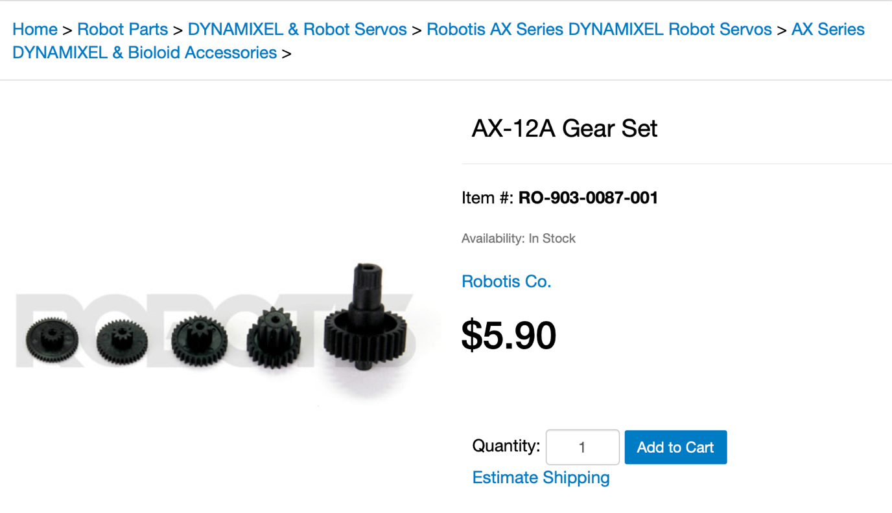
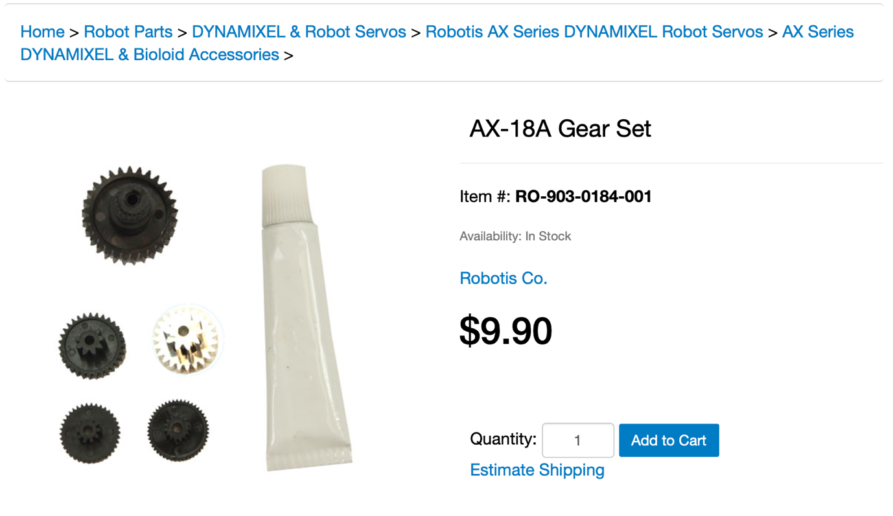

Replacing capacitive bolt integrated turning mechanism

The old version of the AX-12a’s were the AX-12+’s with a big improvement being the turning bit. The upgrade included a plastic stopper, preventing the screws from going all the way through and screwing into the plastic of the servo underneath.

Examples of the damage and difference below.

If there is a working AX-12+ and a broken AX-12a, replace the turning bit.

